ROLFING: A CROSS BETWEEN DEEP TISSUE MASSAGE AND THERAPY
It aims to release your body and your emotions. Louise Chunn takes the treatment
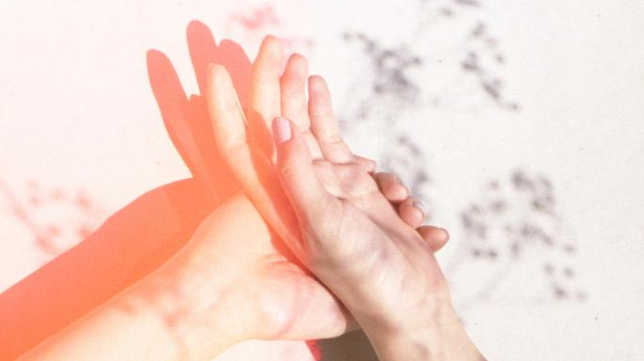
What was I, a down-to-earth, midlife woman in the labour pains of an internet startup, doing lying down in my bra and knickers in broad daylight while a good-looking young man kneaded, poked and pulled at me, sometimes painfully, for more than an hour at a time? I was trying Rolfing, and I must have liked it; I went once a week for almost three months.
Invented in the 1940s by the American biochemist Ida Rolf, Rolfing is a body therapy that focuses on freeing the fascias — the connective tissue surrounding and protecting our tendons, muscles and ligaments. After trauma, or through stress or simple ageing, our fascias tighten; Rolfing, a mix of massage and osteopathic-type movements, aims to bring them back to prime condition.
I met Nico Thoemmes, 31, one of the first people to learn Rolfing in the UK, when I decided to write about the therapy for my wellness website. I was booked in for the 10 Series: 10 weekly sessions, each with a different focus and aim. I had no intention of doing so many — I didn’t have the time and after a couple, I thought, I would have enough to write it up. But I just couldn’t bear to stop.
I knew that Rolfing would help with the stiffness and pain that affects screen-slave workers like me. It’s a constant struggle to fend off the neck cricks and the lower back aches. Many of us get locked into flexion (curling forward and stooping) or extension patterns (overextending, pulling ourselves up and back), and a key Rolfing goal is to make the body more flexible. What I hadn’t expected is how it would affect me emotionally. I would arrive stressing about my business, family, health, money, the parking in Primrose Hill; I would leave unburdened, my muscles softened and my mind and feelings singing quietly rather than screeching in my ears.
Initially, though, it was a pretty shocking experience. I’ve had male masseurs before and I’m not hugely coy, but there was none of that calling the practitioner back into the room when you’re ready etiquette, no strategically placed towel.
So here I was, stripping for this handsome young man. Under his watchful eye, Nico asked me to stand up straight and then walk up and down his small room several times to check my gait. I then lay on a massage table while he applied different forms of pressure and manipulation. Some were like massage strokes, some more like pressure-point massage using his fingers, fists or elbows. Definitely the most challenging was when, without warning, he slid his hand between my legs, up past my buttocks and onto the small of my back, where he would cradle me, with occasional twitches from his fingers, for five minutes or so. The first time, my face pinged into that just-been-goosed look, but I grew to appreciate how this unorthodox move left my sacrum feeling smooth and soft, even pliable. Just warning you.
The mind-body connection, which is more acknowledged in medicine these days, meant that with some touches and stretches, I felt a curious sort of release. During one session I felt very emotional, and Nico told me that people do cry and make connections they feel unable to explain rationally. The American psychotherapist Sharon Farber wrote on the Psychology Today website that “being touched and touching someone else are fundamental modes of human interaction, and increasingly, many people are seeking out their own ‘professional touchers’ and body-arts teachers.” Touching is widely seen as a healing tool, and not just in alternative therapies such as Alexander technique, Feldenkrais and biodynamic massage therapy.
Like me, Farber was plagued by aches and would resort to massage for relaxation, but found that the right kind of touch not only fixed her frozen shoulder, but also made her acknowledge its association with the death of her beloved but difficult mother: “The pain of my loss had lodged itself in my body, and a woman’s warm touch started to release it. It also probably released some oxytocin in me, the hormone of love and attachment. The body speaks when we do not have words for what we are feeling. Touch was needed for me to let go and feel the loss.”
For me, Rolfing was much more intense than the escapism of a massage; I felt I had come closer to myself, not further away. Nico, who originally trained as a dancer, says he is interested in “helping people to stay related to their body sense, because often we are trying to run away from it. We don’t give much importance to staying present in our bodies.”
Compared with my previous experiences of therapy, it was a lot less analytical, but I certainly felt “heard”, which is part of the aim of therapy. I would also say that Nico and I were an example of the “therapeutic alliance” that the psychotherapist Philippa Perry tells me is the key element in good therapy, a connection that need not only be found on the traditional couch, but with, perhaps, your Pilates or mindfulness teacher.
One of Nico’s clients had been abused as a child; talking therapy had helped, but he still felt dissociated from his body. “Rolfing made him feel like a different person, for the first time comfortable in his own body,” Nico told me. “His structure changed, his pelvis dropped, his arms swung, and he realised he’d been holding himself in a tense position for all those years.”
We are so disembodied — we’re British, after all — and these days we may fear being touched because of a media saturated with stories of abuse, or the sexual connotation of being unclothed with a stranger. But once we get past our fears and giggles, it’s a powerful tool for people with physical or emotional issues.
I’ve finished the 10 Series now, but Nico and I have decided that every couple of months, we will still be in touch.

